Week 1 Progress Report
  - Getting Started
Jody Holland
2025-10-20

Progress This Week
- Moved into College and restarted work
- Have determined what funding is available to me through my bursary (£75 a month for books, £3000 over the course for conferences, £500 a year for equipment).
  - Also some osptions for field work funding in SEA
    - Notably the Selena Sun Travel and Research Fund from Trinity
    - Deadline for Applications is the 13th February 2026
    - Covers China, Thailand, Vietnam, Laos, Myanmar (bad idea!), Malaysia, Indonesia, the Philippines ect.
- Started Feasibility Report plan and made good progress
  - Fleshed out background section (500 words)
  - Have aimed to produce a brief overview of the current “state of the science”
  - Pretty happy with the introduction
- Made a flow chart outlining the local leakage methods
  - PDF of flowchart is here
- Began work on a conceptual framework to hypothesise what could induce a landscape to be more or less prone to local leakage
  - Emphasised the context of the economic activities occurring
  - Exploring the concept of “Factor Mobility”
    - A concept taken from New Economic Geography (Krugman etc.)
    - Denotes the degree to which an activity/industry could move across borders and landscapes
    - Incorporates both how mobile the workforce might be and how regionally specific a particular activity might be
  - Also examined how landscape topography could interact with local leakage propensity beyond factor mobility
    - Specifically the positioning on the protected area within the landscape
    - PAs are often located in the most politically convenient places - not the most ecologically critical
    - Could mean that there is little economic pressure on the periphery of projects
    - Could also mean that the people living in the vicinity of the PA have little political or economic power to resist the imposition of a PA
- Read Dasguta’s On Natural Capital
  - Not too much that I hadn’t already been introduced to
  - Was a pretty eloquent framing of ecological damage as a “tragedy of the commons” in absence of accurate pricing of natural captial
- Studied Brodie et al. (2023)
  - Pretty fascinating how they conclude that PAs can have positive impacts on biodiversity across a landscape
  - Notably in the case of mammals they find that PAs could lead to safeguarded source populations
    - That would incur density driven dispersal of animals across a landscape, even if that landscape is degraded habitat
  - This could mean that even if we see elevated habitat destruction around a project there could nonetheless be positive spillovers for biodiversity in the landscape
    - Land Sparing wins again?
- Studied Lui and Coomes (2015)
  - They find no evidence for local leakage
  - Some issues with their approach (no dynamic baselines)
  - Also they don’t explore any link between the relative rate of additionality within projects and any rate of leakage in the buffer
- Set up Quarto website for progress tracking
  - When new reports are made they are automatically rendered as html, word, and pdf formats and added to the site.
- Began testing PACT V3 to see if it it fungible and robust
  - Checked if the sum of additionality from Gola North, Central and South was equal to the additionality reading from running the project as a whole
    - 96.4% the same
  - Started running PACT V3 across 35 placebo projects
- Finished up some of the residual tasks for REDD+ paper
- Began running carbon density analysis on Gola Buffer villages
- Got my head around the Zoology PhD training log
- Had a look at the Choice of Advisors page
  - Currently looking at Lynn Dicks and Ed Turner

Problems Encountered
- College is taking some time paying me my stipend, hopefully will be resolved soon (I have some savings to dip into so not an issue
- Due to not having accommodation, I was unable to attend the induction day, although I have made up for this by attending the safety workshop later, I have yet to meet any other Zoology PhD students other than Robin in Rob’s group
- I’m having difficulties making sure my Feasibility Report sections are succinct and direct.
  - Specifically, what is the core message I want to communicate in the background section?
  - 500 words to summarise the “state of science” around tropical forest leakage
  - Struggling to maintain message discipline
  - Also want to find space to add in ‘Biodiversity Leak’ paper
- With the section on research plan, I’m trying to neatly split the CLOCs and BLOCs concept into individual separated studies
  - Should one chapter be about the nuances and trades offs in building the map and another be its utilities and uses.
  - This is inspired by Ali’s approach to LIFE
    - Paper on how it works
    - Paper demonstrating it’s uses
  - For methods, I’m struggling to determine how detailed I need to be
    - Word limitations are significant *(500-100)
    - I need to determine what isa the appropriate and realistic experimental design for local leakage
    - I think I will include my conceptual framework into the report
- Resources and Costs section
  - A bit confusing, costs at the moment are minimal
  - But this could change if I do field work and an exchange
  - I also plan to attend conferences (BES ect.) should I put this down
- Training
  - Need to find training courses relevant to my aims
    - Hoping to find public speaking training, as well as econometric refreshers
    - Also looking into TESSERA workshops and if they count as training

Plans for Next Week
- Finish Research Aims section of Feasibility Report
  - Make a secondary flowchart outlining CLOCs and BLOCs
- Sign onto a training course to happen in November
- Draft a short field work idea to have in the back-pocket
- Arrange TESSERA training workshop (talk to Keshav at next weeks lab lunch)
- Produce the placebo results of PACT to allow us to know its relative predictive accuracy around the world (for SI of chapter 1)
- Identify the set of REDD+ project and their metadata to run leakage analysis on
- Determine the metrics to be used for damage in leakage analysis
  - Forest cover
  - Extinction Risk
  - Forest Carbon
- Study the following papers for potential reference and guidance for the Feasibility Report.
- Balmford, A., Green, R., & Phalan, B. (2015). Land for Food & Land for Nature? Daedalus, 144(4), 57–75. https://doi.org/10.1162/DAED_a_00354
- Bitariho, R., Akampurira, E., & Mugerwa, B. (2022). Long-term funding of community projects has contributed to mitigation of illegal activities within a premier African protected area, Bwindi impenetrable National Park, Uganda. Conservation Science and Practice, 4(9), e12761. https://doi.org/10.1111/csp2.12761
- Fuller, C., Ondei, S., Brook, B. W., & Buettel, J. C. (2020). Protected-area planning in the Brazilian Amazon should prioritize additionality and permanence, not leakage mitigation. Biological Conservation, 248, 108673. https://doi.org/10.1016/j.biocon.2020.108673
- Gilroy, J. J., Edwards, F. A., Medina Uribe, C. A. M., Haugaasen, T., & Edwards, D. P. (2014). Surrounding habitats mediate the trade‐off between land‐sharing and land-sparing agriculture in the Tropics. Journal of Applied Ecology, 51, 1337–1346. https://doi.org/10.1111/1365-2664.12284
- Malan, M., Carmenta, R., Gsottbauer, E., Hofman, P., Kontoleon, A., Swinfield, T., & Voors, M. (2024). Evaluating the impacts of a large-scale voluntary REDD+ project in Sierra Leone. Nature Sustainability, 7(2), 120–129. https://doi.org/10.1038/s41893-023-01256-9
- Pendrill, F., Persson, U. M., Godar, J., & Kastner, T. (2019). Deforestation displaced: Trade in forest-risk commodities and the prospects for a global forest transition. Environmental Research Letters, 14(5), 055003. https://doi.org/10.1088/1748-9326/ab0d41
- Shahi, K., Khanal, G., Jha, R. R., Bhusal, P., & Silwal, T. (2023). What drives local communities’ attitudes toward the protected area? Insights from Bardia National Park, Nepal. Conservation Science and Practice, 5(2), e12883. https://doi.org/10.1111/csp2.12883
- Silwal, T., Devkota, B. P., Poudel, P., & Morgan, M. (2022). Do Buffer Zone Programs Improve Local Livelihoods and Support Biodiversity Conservation? The Case of Sagarmatha National Park, Nepal. Tropical Conservation Science, 15, 19400829221106670. https://doi.org/10.1177/19400829221106670

Picture of the Week
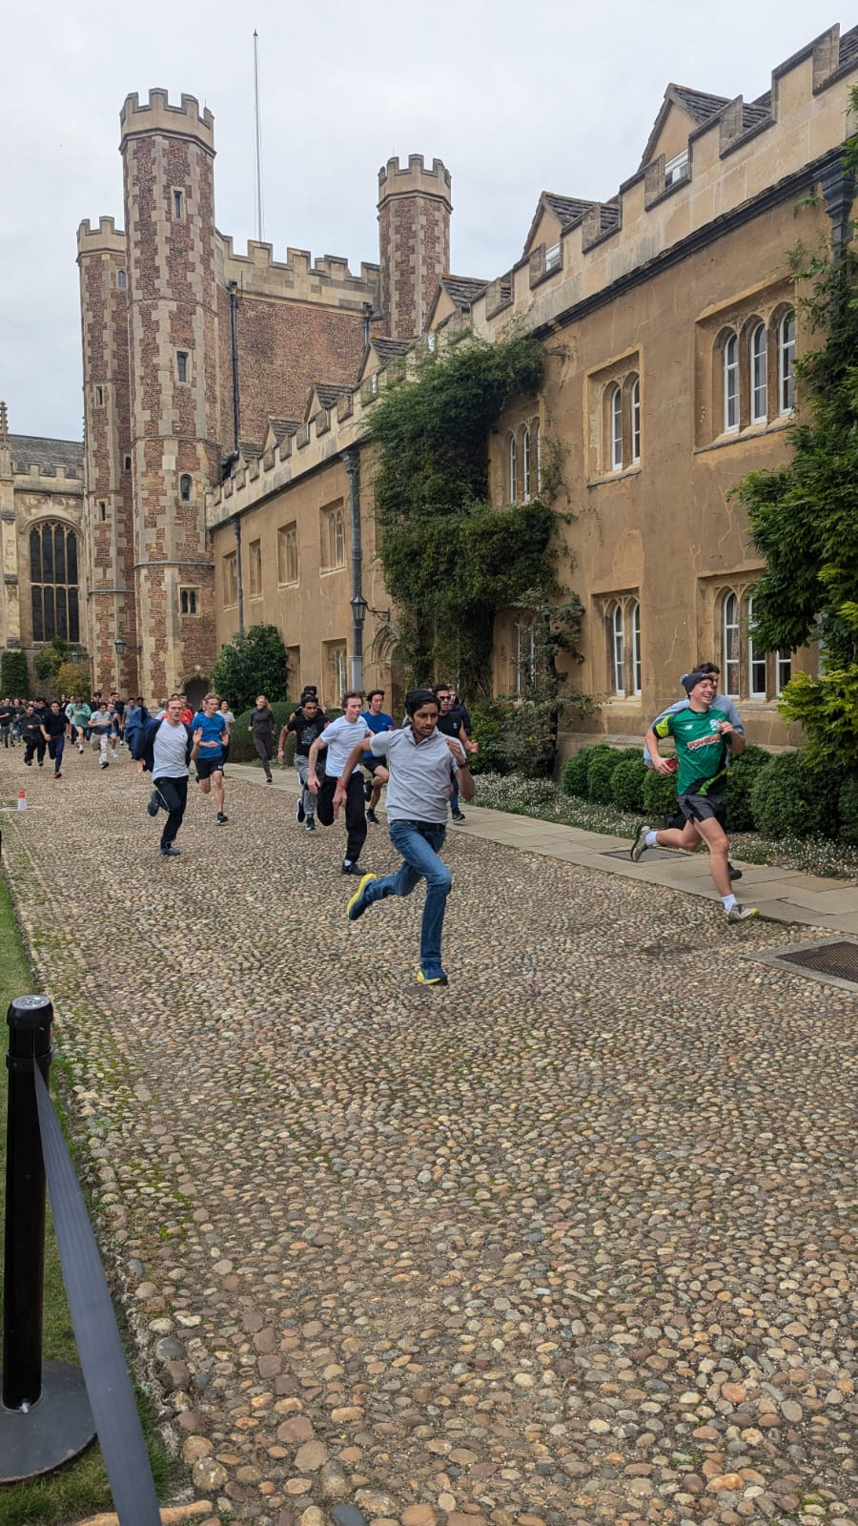
A picture I snapped of the Trinity Great Court Run

Download This Report
- PDF
- Word
- Back to All Reports

First progress report

